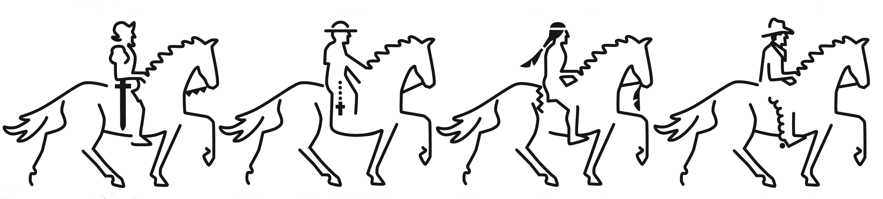
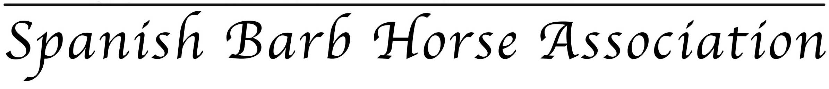
Membership Application/Renewal

Mail the completed form and your check or money order to:
SBHA Membership Or you may join or renew on the SBHA website using PayPal,
4 Shooting Star Ln www.spanishbarb.com/membership
Elgin, AZ 85611-0007

Please circle membership type:

Family or Breeder $60 | Individual $30 | Lifetime $1000 | Supporting $20
Individual or Family owning or leasing a registered Spanish Barb breeding mare or stallion, or two or more family members who own Spanish Barb(s). This membership entitles the Breeder or Family two votes. | Single person who owns Spanish Barb(s). This membership entitles the member to one vote and will cost $30 per year. | Individual or family wishing to make a large donation to support the SBHA. Includes a gift of appreciation. $940 is tax-deductible. Lifetime membership entitles the member to two votes. | Single person who owns no Spanish Barbs but wishes to support the SBHA. This member is entitled to 0 votes

Additional Tax deductible donation: ___________

Name: ______________________________Ranch/Farm Name: _________________________________
Mailing Address: _______________________________________________________________________
Home Phone: __________________________ Cell Phone: ____________________________________
Email: _______________________________________ Website: ________________________________
I am interested in: (please check one)
_____ Owning and/or breeding Spanish-Barbs
_____ Supporting the restoration and preservation of the breed and the goals of the SBHA through a General Membership
Yes or No: Include my telephone number and email address information on the membership list, distributed to members only.
As a member of the Spanish-Barb Horse Association, I agree to abide by the rules and regulations set forth in the SBHA Handbook.

Signature: _______________________________________ Date: ________________

THANK YOU FOR YOUR SUPPORT!

For official use:
Date Received: ______________ Check #/PayPal/Money Order: ______________
Date Processed: ______________

